Results:

Visual Representation:

Analysis of feature

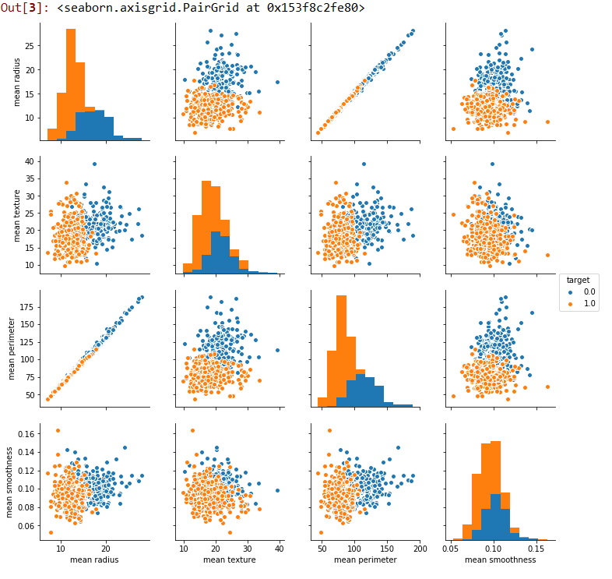

Count graph:

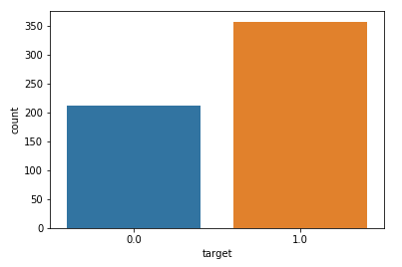

Heat map:

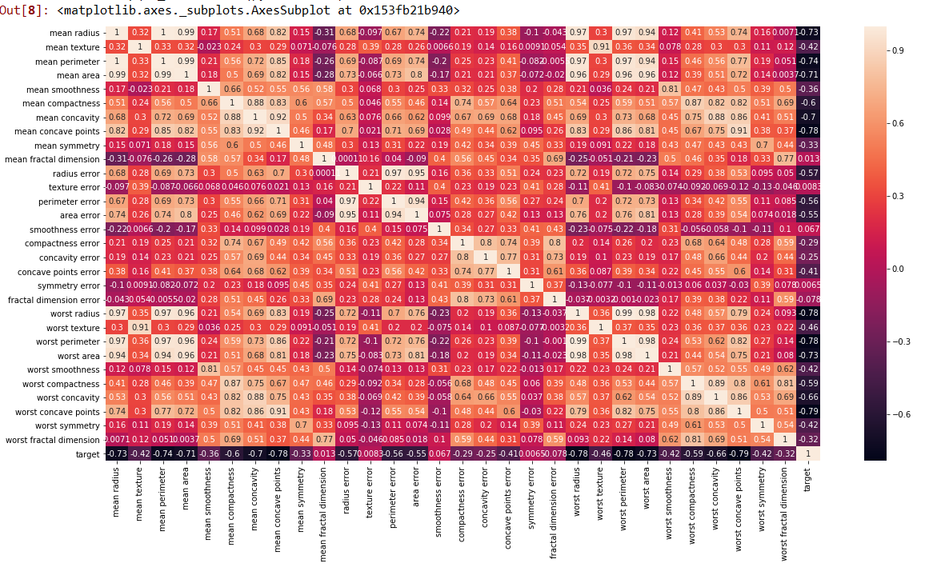

Confusion matrix:

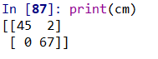

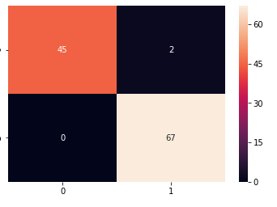

Classification report:

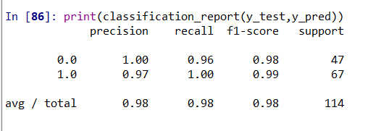

Accuracy:



Conclusion:

* Machine learning is able to classify the tumor in breast with accuracy of 98.2%.
* This technique can rapidly evaluate breast mass and classify them in a automated fashion.
* This technique can dramatically save life especially in developing world.